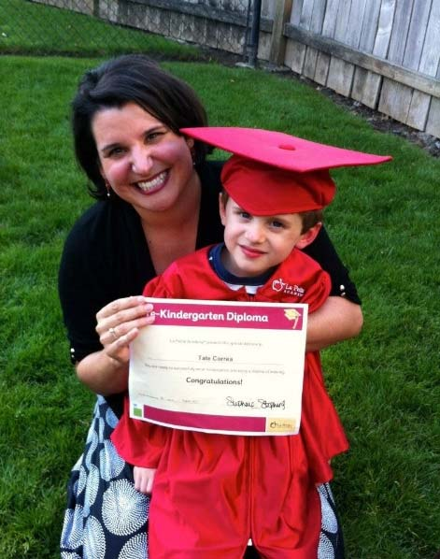
Valerie
Oregon Marrow Transplant Story
The clock started ticking the second Valerie heard her doctor utter the word “leukemia.” It was so serious, she was given 60 minutes to get to the hospital and start chemotherapy. There was no time to cry. No time to be frightened. Instead, there was Tate. As a single mother, the care of her then 6-year-old son was her singular concern. Having counseled children whose parents had died, Valerie knew what to do. But that didn’t make it any easier.
Considering she had just been told over the phone that she had been diagnosed with acute myeloid leukemia (AML), a blood and bone marrow cancer, Valerie Correa felt an emotion that may seem out of place for someone in her situation – reassurance.
The gravity of the situation certainly was not lost on Valerie, a 42-year-old single mother. But she had been nagged by a series of unexplained ailments for the past year – from reoccurring infections and the bizarre sunburn of her eyeballs, to 103-degree fevers antibiotics couldn’t combat. Her doctors never pinpointed the cause until they ran a simple blood test.
“I think most people would be so frightened by that phone call,” Valerie said. “But I was reassured because I had inherently known something was wrong, and now I finally knew what it was.”
By the time she was diagnosed, the cancer’s extended presence had depleted Valerie’s healthy white blood cells down to levels so low, and mass produced leukemia cells at levels so high, that the prognosis was dire. She was told she wouldn’t make it more than a few days, unless she immediately began chemotherapy. Her doctor gave her one hour to get to the hospital’s oncology department.
Valerie scrambled to tie down what aspects of her life she could in the hours before chemotherapy began. She needed to find someone to care for her 6-year-old son, Tate. Valerie is his sole provider. Fortunately, as a single, working-mother, she already had a well-trusted network of family and friends for childcare, fun outings and sleepovers. That network grew and swooped in to care for Tate.
While finding care for Tate was relatively straightforward, finding the right words to tell her little boy that he could lose his mom forever – well, that was heart-wrenching. Having counseled children whose parents had died, Valerie knew what to do. But that didn’t make it any easier. She talked openly to her son about her illness and let him know she had a plan. She would be fighting with all her might to live for him – to watch him grow up. If anything happened to her, if she didn’t make it, his grandparents would raise him. He would be safe and loved.
There was also the matter of Valerie’s thriving private practice. As a clinical psychologist, she had to make arrangements for her 75 clients to continue their treatment with other providers. Some of her clients were cancer survivors or undergoing grief-counseling for lost loved ones. The sudden news of Valerie’s life-threatening illness triggered more trauma and anxiety for some.
Aware that each day was tenuous, Valerie made it a point to post daily Facebook messages to family and friends. “As you all can tell, my son is a miracle in my life and he needs a life with me as his mom,” she wrote in her first Facebook post. “Please pray for my survival for my son.”
The Fight Begins
AML is a fast- growing cancer that develops cancerous cells called leukemic blasts. The blasts grow quickly and crowd out a body’s bone marrow. This prevents the creation of white blood cells, the body’s foot soldiers in the fight against infections, as well as critical red blood cells and platelets.
Like most AML patients, Valerie began her treatment with induction chemotherapy. The intensive treatment aims to bring a person into remission – and that’s exactly what happened to Valerie. It was followed by multiple rounds of consolidated chemotherapy she continued until February 2015.
But the cancer returned in the form of leukemia cutis, in which the cancerous cells manifest themselves on a person’s skin. The American Society for Clinical Pathology reports that leukemia cutis patients follow an “aggressive course and the survival is short,” with nearly 90 percent of patients dying within one year of being diagnosed.
Valerie endured another months-long battery of chemotherapy sessions to rid her body of the cancer, while also contending with multiple infections.
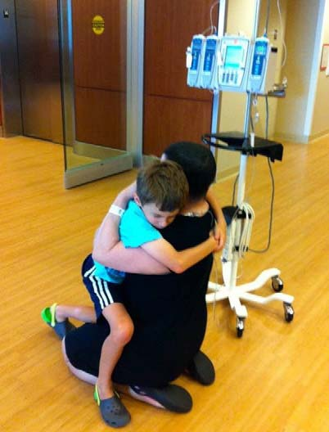
“There were many times I almost died,” she recalled, fighting back her emotions. “I just fought for my son.
I had already lived such a privileged life, but my son needed his mom. Leaving him just wasn’t an option. I told myself that if I can just keep one finger grip onto this life and not let go, he will have his mom.”
Carefully weighing the risks and chances for survival, doctors began searching for a matching marrow donor for a bone marrow transplant. There was concern that Valerie’s diverse ethnic background (Mexican, German, Irish and Polish) would make finding a donor match difficult. To their surprise, 40 matches were found through the Be The Match Registry®, the world’s largest and most diverse listing of potential bone marrow donors.
On Aug. 12, 2014, nearly a year after being diagnosed with AML, Valerie received her transplant at the Oregon Health & Science University Knight Cancer Institute.
The transplant was a success, but like most patients, the most challenging period lie ahead in the 100 days following transplant. During this period, patients are at high risk for infections as they wait for their new stem cells to grow and create blood cells, helping rebuild their immune system. The first 24 hours is the most tenuous. The following days, weeks and months have many ups and downs. But the 100th day post-transplant is a celebration. Patients usually feel a bit stronger by then and doctors know that the risk of fatality starts to drop after the hundred day mark.
Valerie experienced complications including severe mucositis, painful sores of the mucous membranes in the mouth, throat, and gut lining. She also experienced graft versus host disease, in which the donor cells attack healthy cells. Fortunately, there were no lingering life-threatening conditions.
In November, she commemorated her 100th day post-transplant with the news that a recent biopsy showed no leukemia cells in her body.
The Path to Recovery
Valerie’s recovery continues today. Her health is improving and her victories have been small but meaningful – from attending her son’s 8th birthday party with his second-grade class and a school field trip, to her first visit to a bookstore.
She was fortunate to have a health insurance plan that prevented her from going into significant debt while dealing with her cancer, but she still faced financial hardships. As the owner of a practice that could no longer serve patients, she had no income coming in. Student loans and mortgage payments piled up while she was in the hospital. She didn’t even qualify for food stamps despite being unable to work, and eventually she had to sell her home.
Fortunately, Valerie’s friends and family rushed to her aid. They created a GoFundMe page named Val’s Village that raised nearly $15,000 in donations to help cover medical payments and monthly bills.
“I had this amazing team of family, friends, professionals and medical staff taking care of me,” she said. “I had everyone just keeping me alive throughout, and it worked.”
She is also eager to meet her donor. The two are restricted from sharing even their names until the oneyear anniversary of Valerie’s transplant in August. Valerie only knows her donor is a woman in her 50s from Germany.
“I am often thinking about you and I hope my blood will be friendly to you,” the woman wrote to Valerie in an anonymous letter.
Valerie has thought of her donor, too. She and her family hope to fly her out to Portland following the oneyear anniversary to throw a party in her honor.
Meanwhile, Valerie is focused on resuming her life. That includes making plans to take her son on his first trip to Mount Rushmore to indulge in his fascination with U.S. presidents, as well as resuming her practice in September.
“My sense of time will probably never be the same again,” she said. “Things can shift and your life can change so quickly. My grandma is 94, and I always imagined myself living that long. Today, I realize you need to enjoy your life right now.”

